Stochastic Capacity Planning for Airport De-Icing Operations with Nonlinear Recirculation Effects: A Hybrid Analytical/Discrete-Event Simulation Framework

ENG ME 714 Advanced Stochastic Modeling and Simulation
Course Project

Cole H. Shaigec
Boston University
College of Engineering
Table of Contents
Executive Summary ………………………………………………………………………….. 3
Abstract .………………………………………………………………………………………….. 4
Problem Framing………………………………………………………………………………. 5
Cost Model and Decision Objective ……………………………………………………… 6
System Model …………………………….……………………………………………………… 8
Experimental Design ………………….…………………………………………………..… 11
Results …………………………….……………………………………………………………… 13
Comparison of Analytic Model and Simulation Results ……………………….. 26
Limitations and Future Work ……………………………………………………………. 29
Project Code ……………………………………………………………………………………. 31
Selected References …………………………………………………………….…………… 31
Appendix I: Analytic Approximation ……………………………………..…………… 31
Appendix II: DES Methodology ……..……………………………………..…………… 38

Executive Summary
This study evaluates stochastic capacity planning for airport de-icing operations under winter weather conditions using a hybrid analytical/discrete-event simulation (DES) framework. The objective is to determine how de-icing capacity policy, denoted by the pair $(k,e)$, affects operational performance and economic outcomes under congestion, uncertainty, and weather-driven disruption. Here, $k$ denotes the number of de-icing pads and $e$ denotes the service process configuration governing de-icing speed and variability.
The study’s central finding is that downstream taxi/takeoff congestion is the dominant driver of system behavior in the explored search space. Under adverse downstream conditions, longer taxi/takeoff times increase the probability of holdover time (HOT) violations, forcing aircraft to return for repeated de-icing. This recirculation mechanism amplifies congestion by increasing effective workload within the system, producing nonlinear growth in delay, cancellations, and operating cost. Across the tested scenarios, variation in downstream taxi/takeoff conditions produced substantially larger effects than moderate changes in either pad count $k$ or service process configuration $e$.
The simulation results further show that cancellation costs dominate total operating expenditure under the tested cost assumptions, frequently accounting for more than 85% of total operating cost. This finding implies that cancellations should be interpreted not merely as a cost term, but as a system-level feasibility and operational risk outcome. Small changes in cancellation counts can overwhelm comparatively large improvements in delay or fluid usage.
Comparison of the two policy levers reveals that improving service quality $e$generally produces more consistent operational benefit than increasing the number of de-icing pads $k$. Higher service quality reduces non-cancellation operating burden by lowering service times and reducing congestion accumulation within the de-icing subsystem. By contrast, increasing pad count alone provides limited benefit when downstream congestion remains the dominant bottleneck.
The study also demonstrates that operating-cost-optimal policies are not necessarily capital-cost-optimal policies, and optima in OPEX or CAPEX are not necessarily global optima. Once annualized CAPEX is incorporated, aggressive high-capacity policies become economically difficult to justify under moderate weather exposure assumptions. This creates a meaningful tradeoff between robustness and infrastructure cost, with optimal policy depending strongly on long-run weather exposure frequency.
A simplified analytic approximation was developed alongside the DES to provide rapid first-order sensitivity analysis. The analytic model successfully captures several directional congestion effects under moderate operating conditions, including sensitivity to service quality and arrival concentration. However, it materially understates congestion growth and delay in stressed regimes. The primary causes are its first-moment structure, simplified congestion approximation, lack of aircraft-level state tracking, and inability to capture cancellations and path-dependent recirculation effects.
Operationally, the results suggest that de-icing infrastructure investment should not be evaluated in isolation from downstream airport operations. Policies that increase de-icing throughput without improving downstream taxi/takeoff conditions may fail to produce meaningful system-wide benefit. More broadly, the study demonstrates how nonlinear recirculation effects can fundamentally alter congestion behavior in stochastic service systems, producing operating regimes that are poorly captured by simplified first-moment analytical approximations.
Abstract
Airport de-icing operations involve a stochastic capacity planning problem in which insufficient throughput can induce severe congestion, delay, and flight cancellations under winter weather conditions. This study develops a hybrid analytical/discrete-event simulation framework for evaluating de-icing capacity policies under congestion-dependent recirculation dynamics induced by holdover time (HOT) violations. A simplified analytical approximation is constructed using pointwise stationary approximations, heuristic congestion functions, and aggregate flow relationships, while a higher-fidelity discrete-event simulation (DES) models aircraft-level trajectories, queue interactions, repeated HOT violations, and cancellations explicitly. Experimental analysis evaluates the effects of de-icing capacity, service quality, downstream taxi/takeoff congestion, arrival concentration, weather exposure, and cost structure on operating performance and economic outcomes. Results indicate that downstream taxi/takeoff congestion is the dominant driver of system behavior, with HOT-driven recirculation producing nonlinear congestion amplification and cancellation-dominated operating regimes. Improvements in service process quality generally outperform moderate increases in pad count, while CAPEX considerations materially alter the preferred policy. Comparison of the analytical model against the DES shows that the analytical approximation captures first-order directional effects under moderate congestion but materially understates delay and operating burden in high-congestion regimes due to its first-moment structure and simplified treatment of recirculation and congestion dynamics.

Problem Framing
Aircraft de-icing is a critical safety requirement during winter operations, but it introduces a fundamental capacity planning problem for airport operators. Insufficient de-icing throughput leads to congestion, departure delays, flight cancellations, and cascading disruptions across airline networks. At the same time, de-icing capacity is tied to costly physical infrastructure, including specialized machinery, fluid recovery systems, glycol storage, and dedicated apron space. These resources are essential during storm conditions but remain largely idle during normal operations. Airports must therefore balance the cost of maintaining de-icing capacity against the operational and economic consequences of insufficient throughput. This study evaluates that tradeoff and seeks to identify capacity policies that minimize total system cost under stochastic winter conditions.
The operational dynamics of de-icing systems are further complicated by stochastic effects such as holdover time (HOT) constraints, which introduce congestion-dependent feedback and nonlinear system behavior. These dynamics are treated explicitly in the System Model section of the report.
Analysis of de-icing capacity planning is further complicated by its interaction with broader airport operations, including gate scheduling, aircraft dispatch, and runway utilization, as well as by temporal and organizational cost asymmetries. Capital investments in de-icing infrastructure are incurred over multi-year horizons, while operational disruption costs arise at the level of individual storm events. In addition, these costs are distributed across stakeholders, with airports bearing infrastructure costs and airlines bearing delay and cancellation costs.
Rather than modeling these interactions explicitly, this study adopts a simplified scope focused on capacity policy evaluation. Day-level scheduling decisions are not considered. It is instead assumed that work-conserving policies, under which expected system time is largely insensitive to the specific scheduling discipline, are used so that capacity effects can be isolated. Cost analysis is conducted using lumped parameter models rather than full discounted cash flow analysis, and stakeholder incentive misalignments are not explicitly modeled. Instead, policy performance is evaluated from a system-wide perspective using a total cost objective, consistent with a Pareto efficiency framing in which all stakeholder costs are internalized.
Given the complexity of the de-icing process, capacity planning decisions can be defined along many dimensions, including equipment, staffing, and facility layout. In lieu of a fully granular analysis, this study focuses on a simplified capacity policy $(k,e)$ as the primary decision object. De-icing servers are assumed to be independent and identically distributed (i.i.d.), with $k$representing the number of installed servers. The parameter $e$ represents a discrete choice of service regime, where each value of $e$corresponds to a predefined de-icing service process characterized by a specific service time distribution (including both mean and higher-order properties). In this way, $e$captures operational factors such as procedural efficiency, equipment capability, and environmental conditions through their impact on service dynamics. The objective is to select the policy $(k,e)$ that minimizes total expected cost. The influence of key exogenous factors, including cost structure and weather intensity, on this optimal policy is also examined.
The stochastic structure of this system (see System Model) limits the availability of closed-form solutions for many quantities of operational interest. To address this, an analytic approximation is developed to provide tractable insight into system behavior and to enable rapid evaluation of capacity policies. In parallel, a discrete-event simulation (DES) is constructed to capture the full system dynamics, including stochastic variability, congestion effects, and feedback mechanisms. Capacity policies are evaluated primarily using the DES, with the analytic model serving as a complementary tool for interpretation and approximation. The two approaches are compared explicitly, and their respective strengths and limitations in the context of practical de-icing operations are examined.
Cost Model and Decision Objective
Evaluation of the de-icing capacity planning decision begins with definition of the system’s cost structure and an appropriate objective. Two simplified cost models are considered in this study. Both have the structure below:
$$C_{year}\left(k, e\right)≔A\left(k,e\right)+ \sum_{w∈W}{N_{w}\left[C_{op}\left(k,e,w\right)+C_{Delay}\left(k,e,w\right)\right]}$$
where:
- $C_{year}\left(k,e\right)$ is the annual total cost of a given de-icing policy $(k,e)$
- $A\left(k,e\right)≔I\left(k,e\right)\frac{r{\left(1+r\right)}^{L}}{{\left(1+r\right)}^{L}-1}$is a capital recovery factor (CRF) used to annualize de-icing capital expenditure (CAPEX) from initial outlay $I(k,e)$, with discount rate $r$ and average asset useful life $L$
- $w∈W$ represents the set of day-level adverse weather events inducing de-icing requirements in a given operating year, with $N_{w}$ corresponding to the number of events of class $w$ in the specified year
- $C_{op}\left(k,e,w\right)≔C_{activation}+C_{fluid}\left(k,e,w\right)$captures the day-level de-icing operating expenditure (OPEX) for a weather event of class $w$and policy $(k,e)$ via an event-independent resource activation cost proxy $C_{activation}$ and $C_{fluid}\left(k,e,w\right)$ is a day-level de-icing fluid cost
- $C_{Delay}\left(k,e,w\right)$ encodes an increasing piecewise linear day-level delay cost regime that penalizes long ground sojourn times for aircraft
For comparability, the CRF and the underlying weather process $W$ are isomorphic between the analytic model and the DES. The activation cost proxy $C_{activation}$ is an airport property and is assumed to be identical between the DES and the analytic model. However, the two models differ in their calculation of day-level fluid and delay costs, as the greater granularity of the DES allows it to capture cost effects that the analytic model cannot. For instance, fluid usage on a given de-icing job is proportional to aircraft surface area and thus varies by aircraft type. The DES is designed to capture aircraft type heterogeneity (see Appendix II), so it computes day-level fluid cost for the aircraft mix $A$ as:
$$C_{fluid}^{\left(day, DES\right)}\left(k,e,w\right)≔{\sum_{a∈A}{T_{DI}\left(a\right)ξ(w)}c}_{fluid}^{\left(base\right)}$$
where
- $c_{fluid}^{(base)}$ is the baseline per-unit fluid cost, common across all aircraft
- $T_{DI}(a)$ is the total service time at de-icing for aircraft $a$
- $ξ(w)$ is a severity parameter for the weather event $w$, used to scale fluid cost
The analytic model, by contrast, uses i.i.d. service time draws across all aircraft for the sake of tractability. It thus fails to capture fluid cost driven by aircraft type heterogeneity and relies instead on a first moment-driven fluid cost approximation:
$$C_{fluid}^{\left(day, analytic\right)}\left(k,e,w\right)≔c_{fluid}^{\left(base\right)}ξ(w)E[J_{DI}^{\left(airport\right)}]E[T_{DI}]$$
where
- $E[J_{DI}^{\left(airport\right)}]$ is the expected number of day-level de-icing jobs at the airport level
- $E[T_{DI}]$ is the expected de-icing service time
The DES and analytic models also diverge in their treatment of the delay cost. The DES possesses aircraft-level delay information and aggregates it. A piecewise linear structure is employed to apply increasing penalties to delays beyond certain thresholds as:
$$C_{delay}^{\left(day, DES\right)}(k,e,w)≔\sum_{j=1}^{3}{C_{D}^{(j)}D_{j}}$$
where
- $C_{D}^{(j)}$is a cost proportionality constant for a given delay region
- $D_{j}≔\sum_{a∈A}{\max\left\{T_{Ground}^{(a)}-d_{j},0\right\}}$for delay region threshold $d_{j}$ and total aircraft-level ground sojourn time $T_{Ground}^{(a)}$
The analytic model, lacking aircraft-level visibility, again employs a first moment-driven approximation to the delay cost as:
$$C_{Delay}\left(k,e,w\right)≔C_{D}^{\left(1\right)}\max\left\{E\left[T_{Ground}\right]-d_{1}, 0\right\}+C_{D}^{\left(2\right)}\max\left\{E\left[T_{Ground}\right]-d_{2}, 0\right\}+C_{D}^{\left(3\right)}\max\left\{E\left[T_{Ground}\right]-d_{3}, 0\right\}$$
where
- $E[T_{Ground}]$ is the expected ground sojourn time seen by an aircraft on the specified operating day
This tripartite delay cost structure was chosen to balance tractability with the temporally escalating cost structure of flight delays. These approximations are designed to match the dominant first-moment cost drivers while preserving tractability. The DES retains aircraft-level heterogeneity and delay realization information, enabling more granular sensitivity analysis and exposing where first-moment approximations fail.
Having defined an overall cost, it is now possible to define the objective of the capacity planning decision. The optimal policy is defined as
$$\left(k^{⋆}, e^{⋆}\right)≔ {\text{argmin} \atop k,e}C_{year}(k,e)$$
Understanding this optimal policy and the influences that drive it is the primary objective of this study.
System Model
The stochastic structure of the de-icing process (illustrated in Figure 1) is a primary driver of system behavior. This study considers a simplified model of ground operations at a hypothetical large airport under winter storm conditions. Gate operations, airline scheduling, and air traffic control consideration are beyond the scope of this report, so the arrival process to the system is defined at the entrance to the de-icing queue. Aircraft proceed through the de-icing service process and then a taxi/takeoff service process, with the latter acting as a simplified model for the taxiway and runway system an aircraft must traverse before takeoff. Two stochastic properties of this system are of particular interest in this study: congestion-dependent feedback and service time heterogeneity.
First, the system exhibits a congestion-dependent feedback loop. De-icing involves the application of heated fluid to an aircraft’s surface to prevent the formation of ice on key control surfaces. The anti-icing protection provided by this fluid degrades in time. If an aircraft waits too long to take off following de-icing, protection will degrade below a safe level. The safe takeoff time window after de-icing is called the holdover time (HOT), and if an aircraft remains on the ground at HOT expiry, it must be de-iced again. Since taxiway/runway congestion prolongs ground sojourn times by introducing queueing delay, the HOT constraint introduces a congestion-dependent feedback loop. While this can induce repeated re-entry into the de-icing system under sustained congestion, airlines typically cancel flights after a certain number of HOT violations or a certain ground sojourn time is exceeded.
A second essential structural feature of aircraft de-icing is heterogeneity of the service time distribution. De-icing service times cannot be considered identically distributed across customers, as the service time is proportional to aircraft surface area and thereby varies by aircraft type. A more appropriate model is a mixture distribution indexed by aircraft type. Large hub airports in the United States typically see frequent movements of smaller aircraft like the Embraer E175 and Airbus A320, while movements of wide-body aircraft like the Airbus A350 and Boeing 777 occur less frequently. This gives rise to a right-skewed distribution of service times, with infrequently occurring large aircraft inducing a heavy upper tail.
Such a right-tailed structure is also a defensible representation of taxi/takeoff service. In addition to being shaped by ground-level congestion, taxi/takeoff sojourn times are affected by arrivals of inbound aircraft. Arrival bursts induce transient congestion and queue spillbacks in the taxi/takeoff subsystem, producing long sojourn times even under moderate average load and resulting in a right-skewed distribution.
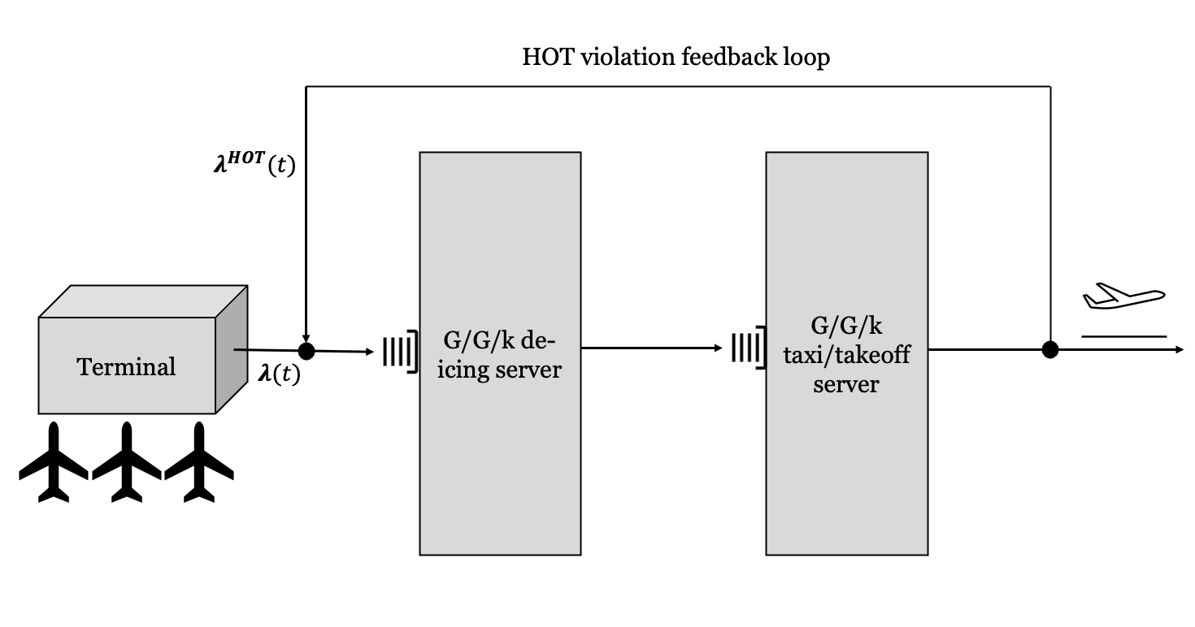
Figure 1: Full System Model
These system properties complicate the application of analytical queueing theory to obtain closed-form expressions for system behavior. For the reasons above, service times at de-icing and taxi/takeoff are necessarily non-exponential, so even with a Poisson service process, Burke’s theorem and Jackson network formulations are not sufficient. Similarly, renewal-theoretic tools assume an arrival process independent of system state. However, the HOT violation feedback loop generates additional arrivals to de-icing that are dependent on past completion times. This congestion-coupled arrival rate renders the process non-stationary and introduces state-dependent arrivals that complicate standard Markovian queueing formulations, thereby precluding clean application of renewal theory to analyze system behavior.
Owing to the aforementioned analytical difficulties, the conclusions and recommendations produced by this study are based primarily on the outputs of the DES. However, a simplified analytic model (Figure 2) is constructed as a fast first approximation to system behavior. This model is a simplified facsimile of the underlying system dynamics. It is intentionally designed as a tractable, approximate analytical scaffold for exploration of system properties and sensitivities. The performance of this model as an approximation to true system properties is later evaluated using the DES. A full explanation of this model and the metrics it computes is found in Appendix I.
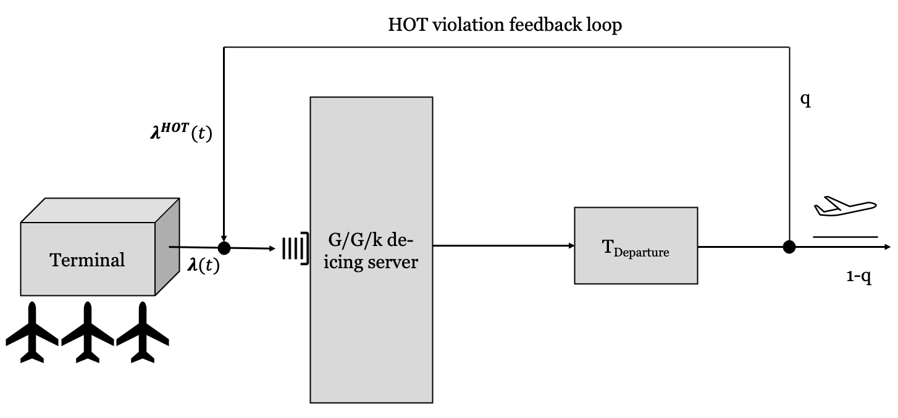
Figure 2: Simplified System Model for Analytic Approximation
The analytic approximation and the simplified model share several key properties while differing in a few important respects.
First, both share the same external arrival process. Schedules at many large hub airports (e.g., Amsterdam Schiphol and Dallas/Fort Worth) include quieter baseline periods punctuated by dense, tightly packed departure banks timed for downstream connecting traffic. Instead of modeling an elaborate arrival process in full, this study uses a simplified, Gaussian-modulated non-homogeneous Poisson arrival process model aimed at exploring the “quiet baseline and dense peak” phenomenon:
$$λ\left(t\right)≔ λ_{base}+λ_{peak}\exp\left\{\frac{-{\left(t-t_{0}\right)}^{2}}{2σ_{λ}^{2}}\right\}$$
where
- $λ_{base}$ is the “quiet period” baseline arrival rate
- $λ_{peak}$ is the amplitude of the arrival pulse
- $t_{0}$ is the time at which the arrival process peaks in intensity
- $σ_{λ}$ is a pulse width parameter modulating the temporal distribution of the arrival peak
Arriving aircraft enter the de-icing system and are enqueued if no de-icing servers are available. The de-icing system is analyzed as a G/G/k queueing system in both the full model and the analytic approximation. While the external arrival process is Poisson, the HOT arrival process need not be. Thus, the superposition of the external and HOT arrival processes may not be Poisson, so an M/G/k model is not used.
To balance tractability and operational realism, a Gamma distribution is chosen for the de-icing service time. A Gamma mixture model indexed by aircraft type is used to capture service time variation across aircraft types in the DES, while the analytic approximation assumes i.i.d. service times across all aircraft and samples from a single Gamma distribution. The sampling strategies used are outlined in Appendix I (analytic approximation) and Appendix II (DES).
A significant difference between the analytic model and the DES arises in the treatment of taxi/takeoff service times.
The DES models taxi/takeoff as another G/G/k queue. Taxi/takeoff service times are modeled as independent of aircraft type, reflecting the dominance of congestion and runway sequencing effects over aircraft-specific characteristics. Thus, the DES samples taxi/takeoff service times from a single shared Gamma distribution.
Owing to the complex dependencies within this system and the failure of standard Jackson network formulations, the analytic model avoids use of a second queueing system to preserve tractability. Instead, it samples taxi/takeoff service times using a single lumped-parameter model $T_{Departure}$. This model is constructed using a heuristic approximation aimed at capturing congestion effects, and it is subjected to a sweep in code to evaluate its sensitivity to key parameters.
Finally, the DES and the analytic model differ in their treatment of HOT violations. The event-driven nature of the DES allows it to capture HOT violations at the aircraft level and route individual aircraft according to their state. To prevent perpetual recirculation, the DES uses a simplified flight cancellation policy: an individual flight is cancelled immediately upon its second HOT violation. The analytic approximation, by contrast, lacks this aircraft-level visibility. It thus attempts to approximate the HOT loop using congestion-dependent Bernoulli splitting, with the HOT violation probability $q$ being constructed using a heuristic approximation aimed at capturing congestion effects. It does not explicitly capture cancellations. In both models, aircraft leave the system by taking off (i.e., upon taxi completion within the HOT constraint). The DES also purges aircraft via cancellations.
Experimental Design
This study evaluates de-icing capacity planning policies using a modular simulation framework that enables controlled variation of system conditions. The experimental design is structured to isolate how capacity, service quality, demand structure, downstream congestion, and economic assumptions jointly influence system performance.

Decision Variables
The de-icing policy is defined by two parameters: the number of de-icing pads (k) and the service process configuration index (e). The former represents the number of servers in the G/G/k de-icing subsystem, while the latter is a discrete selector over predefined operating regimes representing different levels of service speed, variability, and operational discipline, implemented through different service-time distributions and congestion sensitivities.
Three operating configurations exist for selection via $e$, each with increasing cost:
- Baseline: slower service, higher variability
- Upgraded: moderate service speed, moderate variability
- High-end: faster, lower-variance service

Experimental Factors
Each policy (k, e) is evaluated across a set of controlled scenario variations designed to isolate key drivers of system behavior. Some key variations are outlined below:
Arrival Structure (Demand Timing)
Aircraft arrivals follow a time-varying stochastic process. The temporal concentration of arrivals is varied while holding total demand approximately constant. This isolates whether congestion is driven by peak intensity rather than total volume.
Taxi/Takeoff Process (Downstream Congestion)
Three regimes are considered: smooth (low congestion), baseline, and volatile (high congestion and variability). This isolates the impact of downstream bottlenecks on de-icing performance.
Weather Process (Frequency + Severity)
Storm frequency is varied across scenarios (8, 16, and 28 events per year) to evaluate how exposure to winter conditions affects system performance. Storm severity is modeled stochastically and held fixed within each experiment.
Cost Structure
Multiple cost scenarios are evaluated, including balanced baseline costs, delay-sensitive operating costs, and high fluid cost scenarios. This allows separation of physical system behavior from economic prioritization.

All model parameters are explicitly defined in the simulation configuration and are available in the accompanying codebase for reproducibility (see Project Code section).

Controlled Design Principles
To ensure meaningful comparisons, several controls are enforced within the experimental design. Key controls include the following:
- Total demand is held approximately constant when varying arrival structure.
- Physical system parameters are fixed when evaluating cost sensitivity.
- Experiments vary one class of factors at a time where possible.
- Multiple stochastic replications are used for key scenarios.
These controls allow observed differences to be attributed to the intended experimental variables rather than confounding variation.

Performance Metrics
System performance is evaluated using both operational and economic metrics.
Operational metrics include departures, cancellations, cancellation rate, HOT violations, and delay-related measures.
Economic metrics include total operating cost and cost breakdown by component.
Because cancellation penalties can dominate total cost, results are interpreted using both total cost and non-cancellation operating cost (delay, fluid, and activation components).

Research Questions
The experimental design is structured to answer the following questions:
- How should airports trade off pad capacity k and service quality e?
- How does downstream taxi/takeoff congestion affect system performance?
- Does temporal concentration of arrivals materially impact congestion?
- How does storm frequency affect system behavior?
- How sensitive are results to cost assumptions?
- Under what conditions do cancellation-driven failure regimes emerge?

Analytic Model Comparison
For each scenario, an analytic approximation is also evaluated. These predictions are used to assess where simplified models capture or fail to capture the stochastic dynamics observed in simulation.
Results
This section evaluates de-icing capacity policies under stochastic winter operations using DES. Early experiments revealed that cancellation penalties can dominate total cost and obscure operational tradeoffs. Accordingly, results are reported using both total cost and non-cancellation operating cost, and cancellations are interpreted as a feasibility/risk outcome rather than purely an economic one.
Key Result 1: Baseline system behavior
The baseline operating regime is first characterized using the experimental framework defined above. Each policy $(k, e)$is evaluated under controlled arrival processes, taxi/takeoff regimes, weather environments, and cost structures. This section summarizes the aggregate behavior observed across these scenarios prior to isolating individual effects.
Across all experiments, daily demand is held approximately constant by construction of the arrival process. Mean external arrivals are consistently in the range of approximately 50–52 aircraft per storm day across all arrival-structure scenarios, confirming that differences in system performance are not driven by variation in total demand but rather by its temporal distribution.
Despite this moderate demand level, the system exhibits persistent congestion. Cancellation rates are typically in the range of approximately 0.30–0.35 across the controlled experiments, indicating that roughly one-third of aircraft fail to depart under baseline conditions. At the same time, the system does not collapse into full infeasibility: departures continue to occur in all scenarios, and unresolved aircraft counts at the end of the simulation horizon are negligible. This places the system in a mixed congestion regime in which capacity is strained but not fully saturated.
A key driver of this behavior is the recirculation mechanism induced by HOT violations. On average, the system experiences approximately one HOT violation per external arrival, implying that a substantial fraction of aircraft require repeated de-icing before successful departure. This effectively increases the internal workload of the system beyond the exogenous arrival rate, amplifying congestion effects within the de-icing and downstream taxi/takeoff subsystems.
From an economic perspective, system behavior is dominated by disruption-related costs. Across the refined experimental scenarios, cancellation costs account for approximately 85–95% of total operating cost, with delay costs contributing roughly 5–10% and fluid costs typically below 5%. For example, in the balanced baseline cost scenario, mean daily operating cost is on the order of $190k, while non-cancellation operating costs (delay, fluid, and activation combined) are approximately $10–15k per day. Similar cost structures are observed across arrival-density, service tradeoff, and weather sensitivity experiments.
This cost composition has important implications for interpretation. Because cancellations dominate total cost, small changes in cancellation counts can overwhelm more gradual improvements in delay or fluid usage. Accordingly, results are evaluated using both total operating cost and non-cancellation operating cost, with cancellations also treated as a feasibility and risk metric rather than purely a continuous economic term.
Within this regime, downstream conditions play a critical role. Variation in the taxi/takeoff process, as defined in the experimental design, produces large shifts in system behavior. Smooth taxi conditions are associated with substantially lower cancellation rates and operating costs, while volatile taxi conditions produce significantly higher HOT violations, longer sojourn times, and elevated cancellation risk. This indicates that downstream congestion can act as a primary amplifier of system stress, independent of de-icing capacity choices.
In summary, the baseline results indicate that the modeled airport operates in a persistent but non-catastrophic congestion regime characterized by stable demand, significant recirculation, and high sensitivity to downstream conditions. This regime is sufficiently stressed to expose meaningful tradeoffs between capacity $k$, service configuration $e$, and system environment, while remaining stable enough to support controlled comparative analysis across scenarios.
Key Result 2: Cost decomposition + cancellation dominance
The DES results were decomposed in an effort to understand the determinants of operating cost. This cost decomposition (Figure 3) shows that the total operating cost is dominated by cancellations rather than fluid or delay costs. This result is consistent with the baseline regime described above: once HOT recirculation produces repeated service cycles, cancellation becomes the primary economic failure mode.
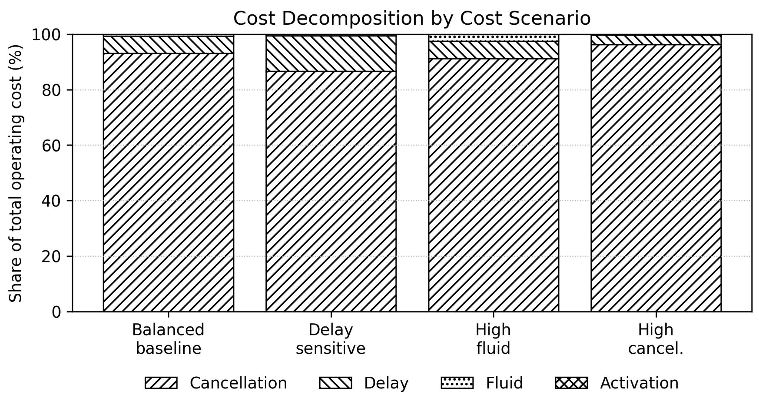
Figure 3: Cost Decomposition by Experiment Scenario
Cancellation costs account for the majority of total operating expenditure across all cost scenarios. Under the balanced baseline cost scenario, cancellation costs represent approximately 93.2% of total operating cost, while delay costs represent 6.2%, fluid costs 0.7%, and activation costs are negligible. Even when delay costs are increased in the delay-sensitive scenario, cancellation remains the largest component at approximately 86.7% of total cost. Under the high-fluid-cost scenario, fluid cost rises to approximately 2.5% of total cost, but cancellation still accounts for approximately 91.2%.
A compact cost breakdown is shown in Table 1:
Cost Scenario | Cancellation Share | Delay Share | Fluid Share | Mean Daily Operating Cost
Balanced baseline | 93.2% | 6.2% | 0.7% | $191.6k
Delay sensitive | 86.7% | 12.7% | 0.6% | $203.9k
High fluid cost | 91.2% | 6.3% | 2.5% | $196.0k
High cancellation cost | 96.3% | 3.4% | 0.3% | $368.1k
Table 1: Cost Decomposition by Experiment Scenario
This decomposition suggests that cost is not a smooth proxy for ordinary operating efficiency. Small changes in cancellation counts can dominate larger proportional changes in delay or fluid usage. Accordingly, subsequent results interpret cancellations as a feasibility and risk outcome, while non-cancellation operating cost is used to study delay, fluid, and activation effects more directly.
This finding also limits the strength of conclusions about fluid cost sensitivity. In the current cost model, fluid cost remains a secondary driver even in the scenario where its cost is perturbed upward to explore its effect. Thus, fluid economics may affect marginal operating cost, but they do not dominate the policy decision within the tested parameter range.
Key Result 3: Impact of taxi/takeoff process
Arguably the most consistent and operationally significant result across all experiments is the dominant role of the downstream taxi/takeoff process in determining system performance. While de-icing capacity parameters $(k,e)$ affect delay and throughput at the margin, variation in taxi/takeoff conditions produces order-of-magnitude changes in both operating cost and cancellation behavior.
Across the experiment search grid, increases in taxi/takeoff service time volatility translate into dramatic rises in operating cost and cancellation rates (Figure 4). The effect size is significantly larger than that observed for variations in pad count $k$, service configuration $e$, or arrival structure $σ_{λ}$.

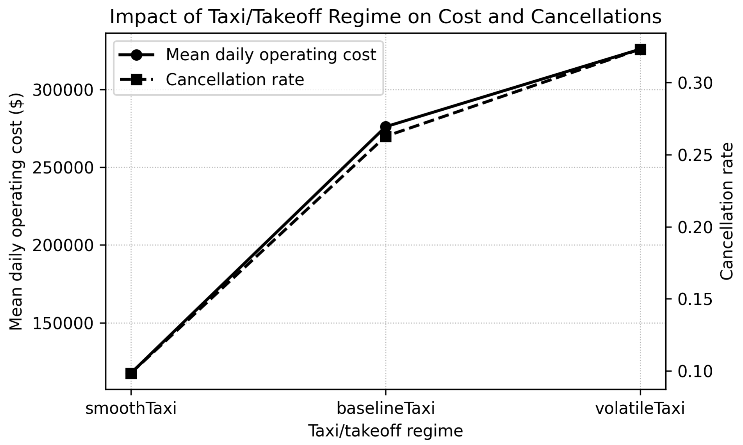
Figure 4: Impact of Taxi/Takeoff Regime on Cost and Cancellations
The mechanism underlying this result is structural and emerges consistently across scenarios: longer and more variable taxi/takeoff times increase the probability of HOT violations. Each violation forces a return to de-icing, increasing the effective system workload via recirculation. This recirculation amplifies congestion within both the de-icing and taxi/takeoff subsystems, producing longer queues, higher delay, and ultimately increased cancellation risk. In high-variability regimes, this feedback loop becomes self-reinforcing: congestion increases HOT violations, which further increases congestion.
Importantly, this is an effect that capacity planning decisions cannot easily modulate. While increasing the number of de-icing pads $k$ or improving service configuration $e$can reduce delay within the de-icing subsystem, these changes do not directly mitigate downstream congestion. As a result, their impact is limited when taxi/takeoff conditions are poor. By contrast, improvements in downstream conditions reduce both delay and cancellation risk simultaneously by breaking the recirculation feedback loop.
This result also sheds light on the earlier cost decomposition. Since cancellations dominate total operating cost, and cancellations are strongly driven by downstream congestion, it follows that taxi/takeoff conditions indirectly control the majority of system cost. This explains why variations in fluid cost, arrival structure, and even service quality exhibit comparatively smaller observed effects on total cost.
From an operational perspective, this result suggests that the de-icing capacity planning decision cannot be made in isolation. Policies that increase de-icing throughput without addressing downstream congestion may fail to deliver meaningful performance improvements. Conversely, improvements in taxi/takeoff efficiency—whether through operational coordination, scheduling, or infrastructure—can produce disproportionately large gains by reducing both recirculation and cancellation risk.
Key Result 4: Policy effects (k versus e)
The simulation results indicate that the service process configuration e has a clearer and more consistent effect on operating performance than the number of de-icing pads k. This distinction is important because k and e represent fundamentally different forms of investment: k expands parallel de-icing capacity, while e improves the quality and efficiency of service at each individual pad.
Figure 5 shows the effect of service process configuration on both non-cancellation operating cost and cancellation rate. A clear monotone trend is visible in the operating cost curve: increasing e from the baseline configuration to the high-end configuration steadily reduces mean daily non-cancellation operating cost. This suggests that improvements in service speed and service reliability reduce queueing burden and repeated de-icing workload within the system.
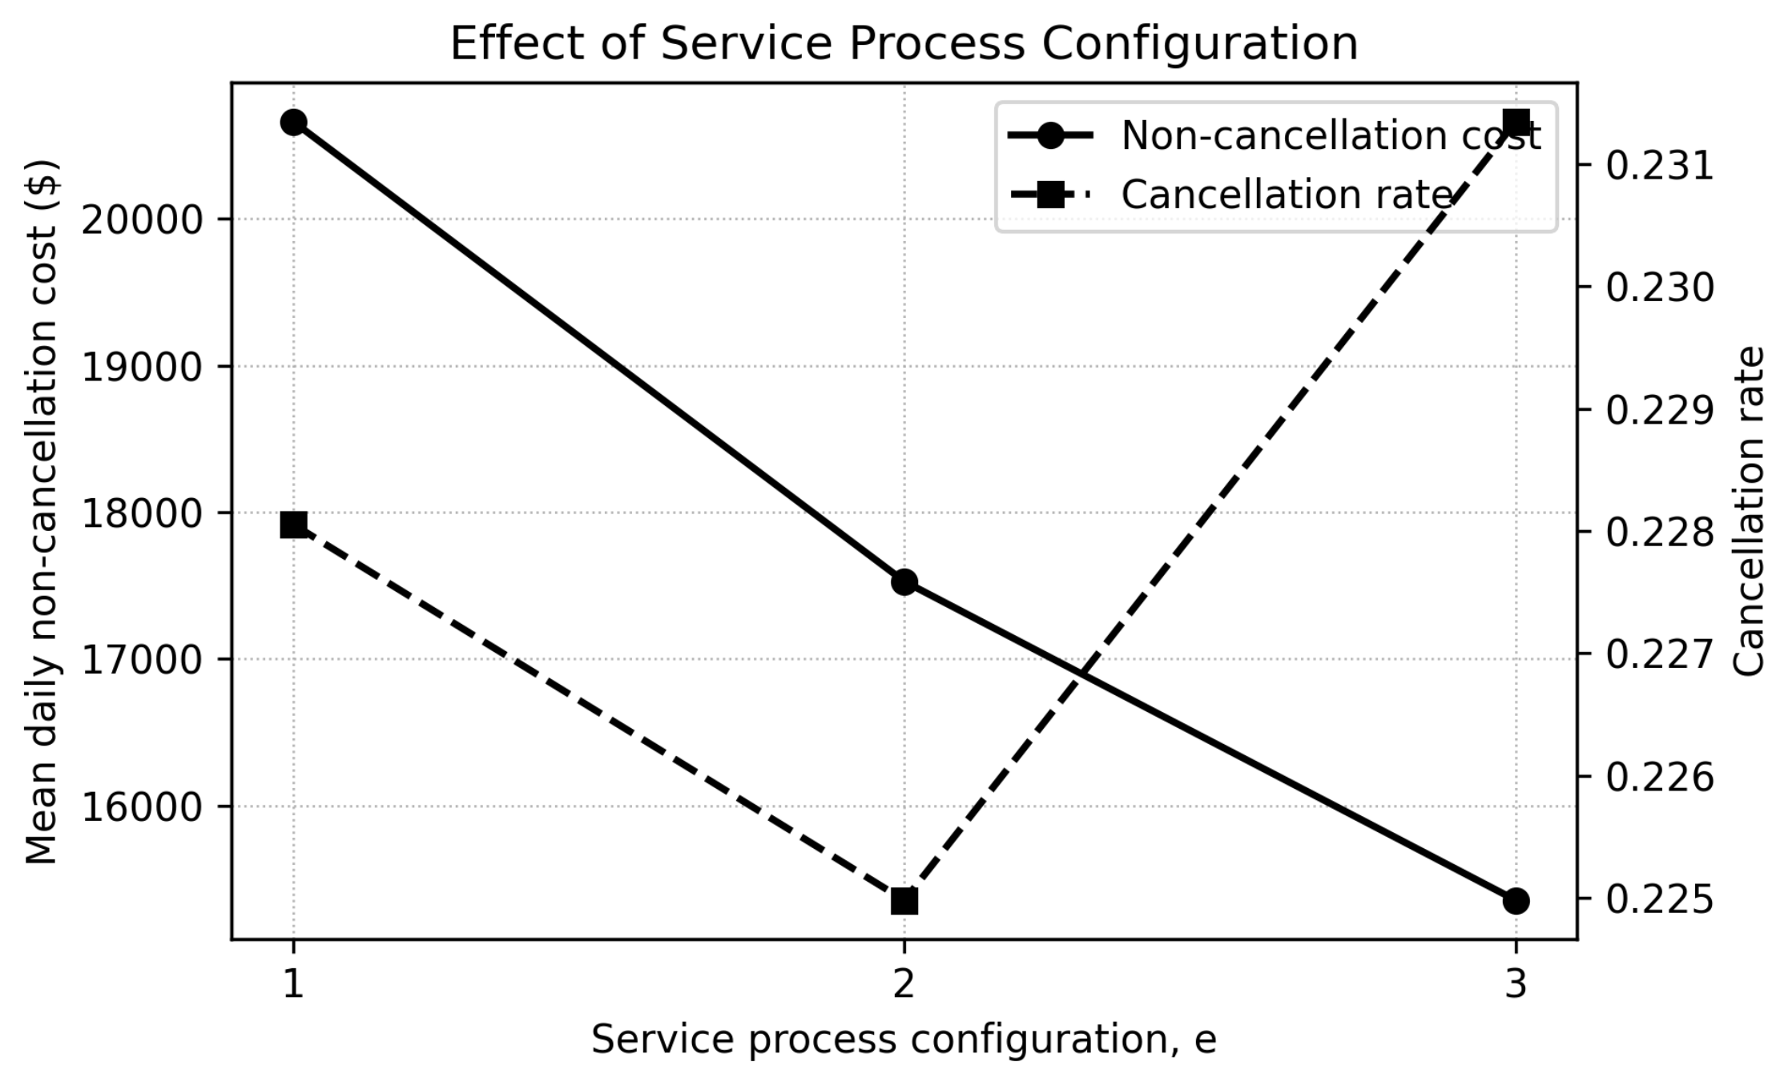
Figure 5: Effect of Service Process Configuration on Cancellation Rate and Non-Cancellation Cost
By contrast, the cancellation rate is non-monotonic across the three service configurations and exhibits small but variation. This implies that, although higher $e$ improves ordinary operating performance, it does not materially reduce cancellation risk within the tested scenarios. This is an important result: the primary operational benefit of improving $e$ appears to be reduced delay and operating burden rather than elimination of high-cost system failure modes.
By contrast, Figure 6 shows that the effect of pad count k is substantially weaker and less structured. Non-cancellation operating cost changes only modestly across the tested range of pad counts, and intermediate values do not exhibit a clean monotone trend. Similarly, cancellation rate fluctuates slightly but remains approximately constant across all values of $k$. The absence of a strong monotonicity suggests diminishing or noisy marginal returns to additional de-icing pads within the tested operating regime.
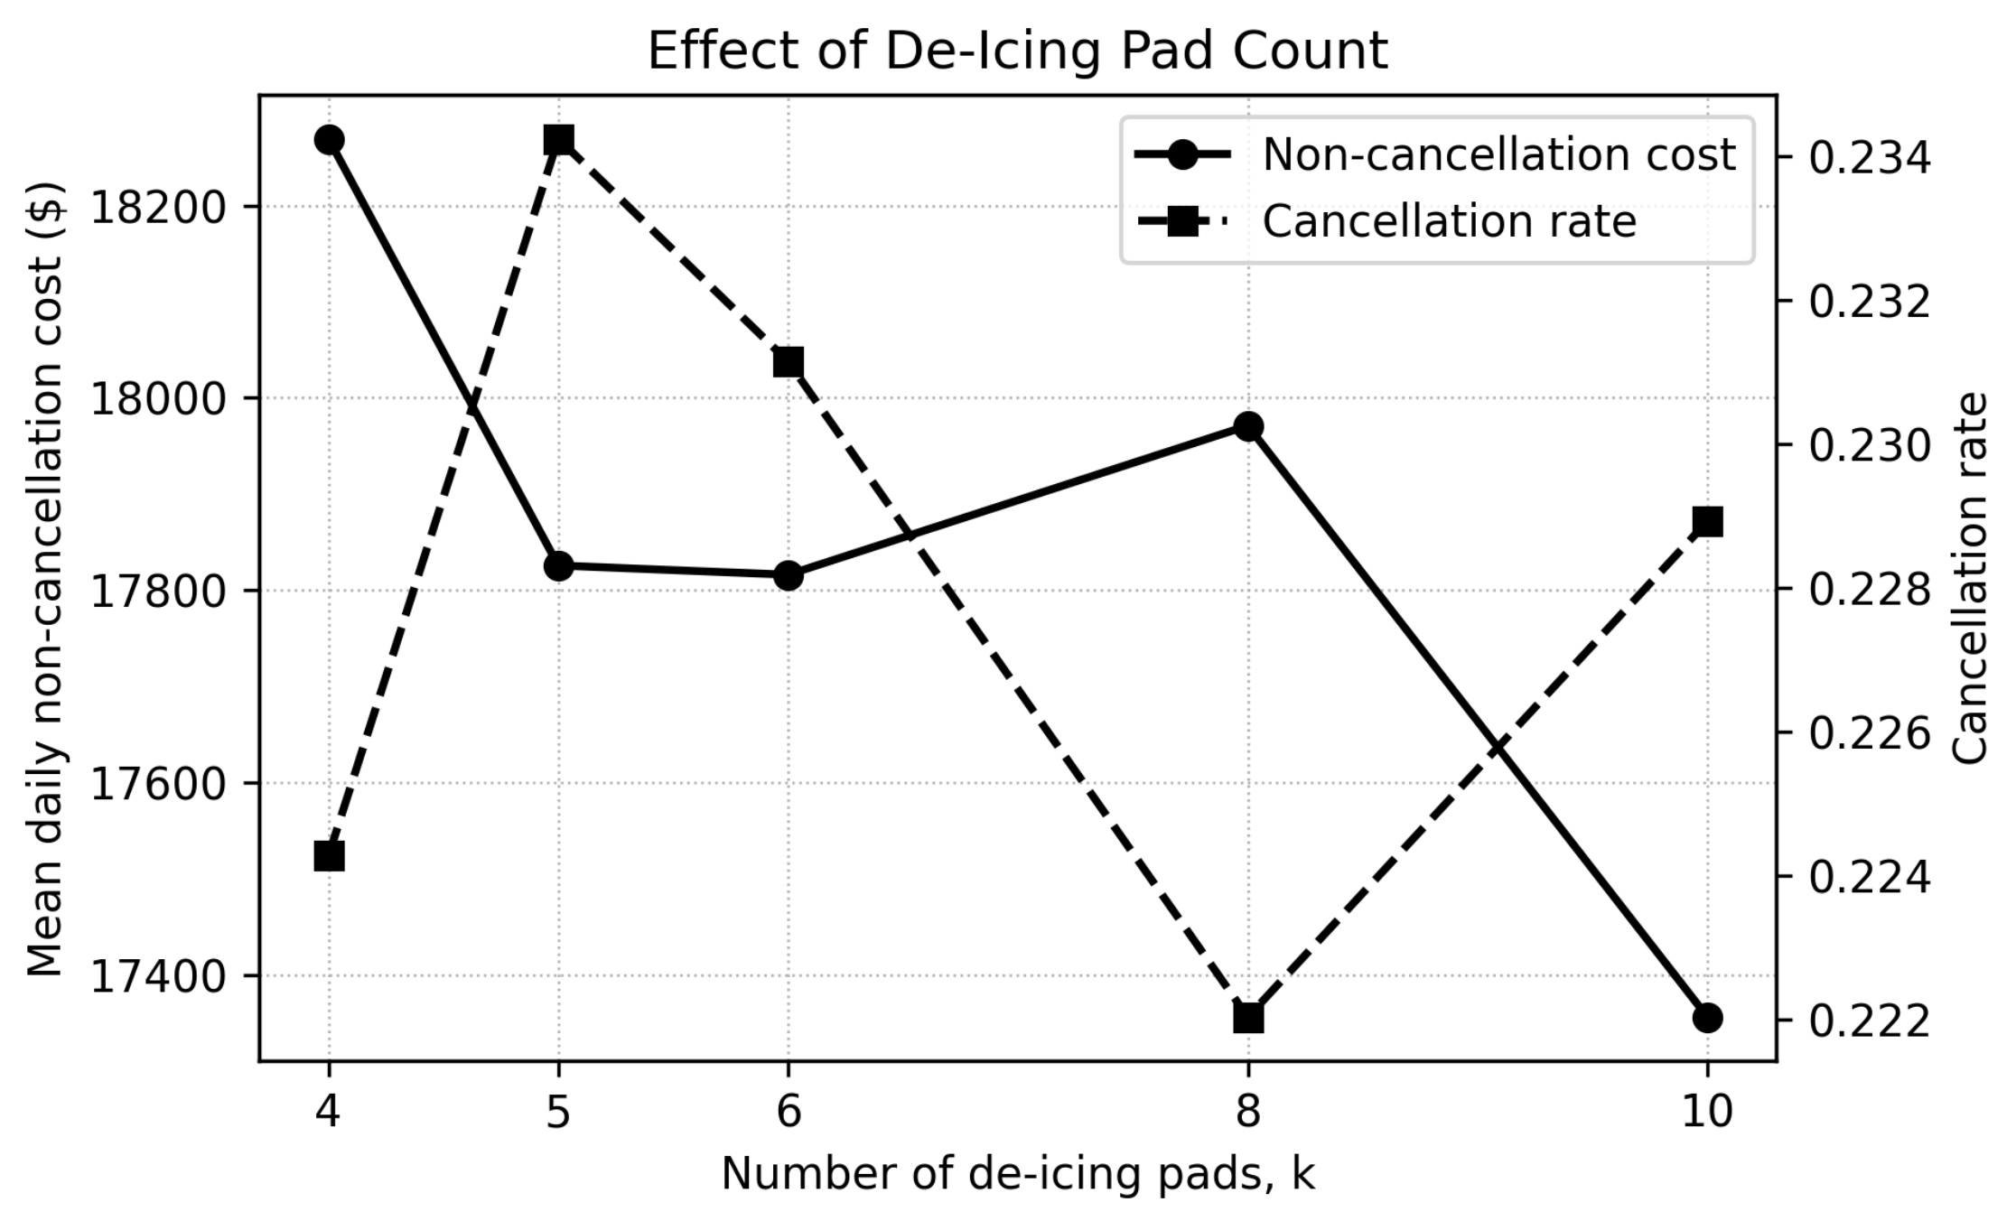
Figure 6: Effect of De-Icing Pad Count on Cancellation Rate and Non-Cancellation Cost
The difference between Figures 5 and 6 is operationally important. Improvements in $e$ directly affect the quality of the de-icing service process itself by reducing service time and variability. Increasing k, however, only expands parallel capacity. Once downstream taxi/takeoff congestion becomes the dominant bottleneck, simply adding additional de-icing pads provides limited system-wide benefit.
This interpretation is reinforced by the joint policy surface shown in Figure 7. The dominant trend in this heatmap is vertical rather than horizontal: moving from $e = 1$to $e = 3$ consistently reduces non-cancellation operating cost, while movement across $k$ produces comparatively smaller changes. The lowest-cost operating region generally occurs at high service quality, particularly $e = 3,$ whereas variation across pad count remains relatively modest.
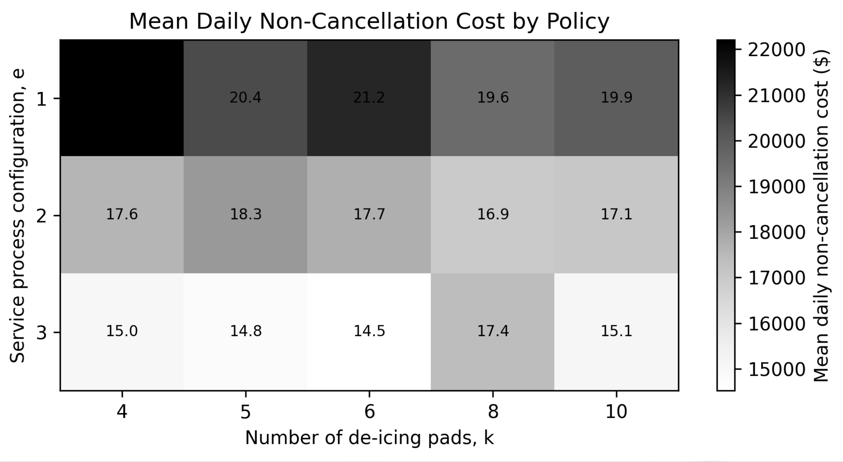
Figure 7: Variation in Mean Daily Non-Cancellation Cost by Policy
However, these results should not be taken to imply that $k$ is irrelevant. Rather, within the tested range, the marginal benefit of additional de-icing pads appears highly dependent on downstream operating conditions. When taxi/takeoff congestion remains severe, the system experiences recirculation-driven congestion amplification regardless of moderate increases in de-icing capacity.
The cancellation rate curves further reinforce this interpretation. Neither higher $e$ nor higher $k$ reliably suppresses cancellations because cancellations are primarily driven by downstream congestion and repeated HOT violations rather than de-icing throughput alone. Thus, the system appears more sensitive to downstream operational conditions than to moderate increases in nominal de-icing capacity.
From an operational perspective, these results suggest a tradeoff between installed capacity expansion and service rate improvement. Adding de-icing pads increases nominal capacity, but its marginal benefit may be constrained if downstream taxi/takeoff congestion remains binding. Improving service quality, by contrast, more directly reduces de-icing delay and repeated service burden. Nevertheless, under adverse downstream conditions, neither lever alone is sufficient to fully control cancellation risk.
Key Result 5: Temporal structure of arrivals
The temporal structure of arrivals produces measurable but comparatively modest effects relative to downstream taxi/takeoff conditions. Narrow arrival peaks increase congestion by concentrating demand into shorter time windows, while broader peaks distribute workload more evenly over time. The sensitivity to arrival concentration increases under stressed operating conditions, particularly when downstream taxi/takeoff congestion is severe. Consistent with queueing intuition, broader arrival distributions generally reduce delay and operating cost, and narrower peaks exhibited greater adverse consequences under high utilization.
However, the magnitudes of these effects were substantially smaller than that observed for taxi/takeoff variability and congestion. Across the tested scenarios, changes in $σ_{λ}$ alter operating behavior directionally but do not fundamentally change the dominant congestion regime of the system. In particular, cancellation behavior remains primarily governed by downstream recirculation dynamics rather than arrival concentration alone.
Operationally, this suggests that temporal smoothing of departure banks may provide incremental performance benefits, but arrival structure alone is unlikely to resolve severe congestion when downstream taxi/takeoff conditions remain poor.
It is noted that the experiment’s parameter sweeps were not sufficiently broad to definitely prove the above effects.
Key Result 6: Impact of weather process
Increasing storm frequency predictably increases annual operating burden by exposing the system to a larger number of de-icing events per year. This effect appears primarily through accumulation of disruption exposure (and thus cost) rather than through qualitative changes in daily operating dynamics.
Importantly, the present experiments varied storm frequency explicitly but did not independently perturb the storm severity distribution across scenarios as a result of experimenter error. Storm severity remained stochastic under a fixed distributional specification. As a result, the study supports conclusions regarding exposure frequency more strongly than conclusions regarding severity sensitivity.
This represents a limitation of the current experimental design. Because storm severity directly affects fluid usage and potentially downstream congestion pressure, a controlled severity sweep would likely be valuable in future work. Nevertheless, the existing results suggest that downstream congestion and HOT recirculation dynamics remain dominant drivers of system behavior even under varying weather exposure levels.

Key Result 7: CAPEX versus OPEX
The CAPEX analysis changes the interpretation of the operating-cost results. Looking only at DES operating cost, higher service quality can appear attractive because improved service reduces delay and repeated de-icing workload. Once annualized capital cost is included, however, the preferred policy shifts toward lower-capacity and lower-service configurations.
Figure 8 illustrates this tradeoff. The operating-cost component varies across policies, but the capital-cost component increases substantially as $k$ and $e$ rise. In the operations-only view, policies with higher service quality can perform well because they reduce non-cancellation operating burden. In the combined-cost view, that benefit must be large enough to justify the capital outlay for additional pads or more advanced service processes.
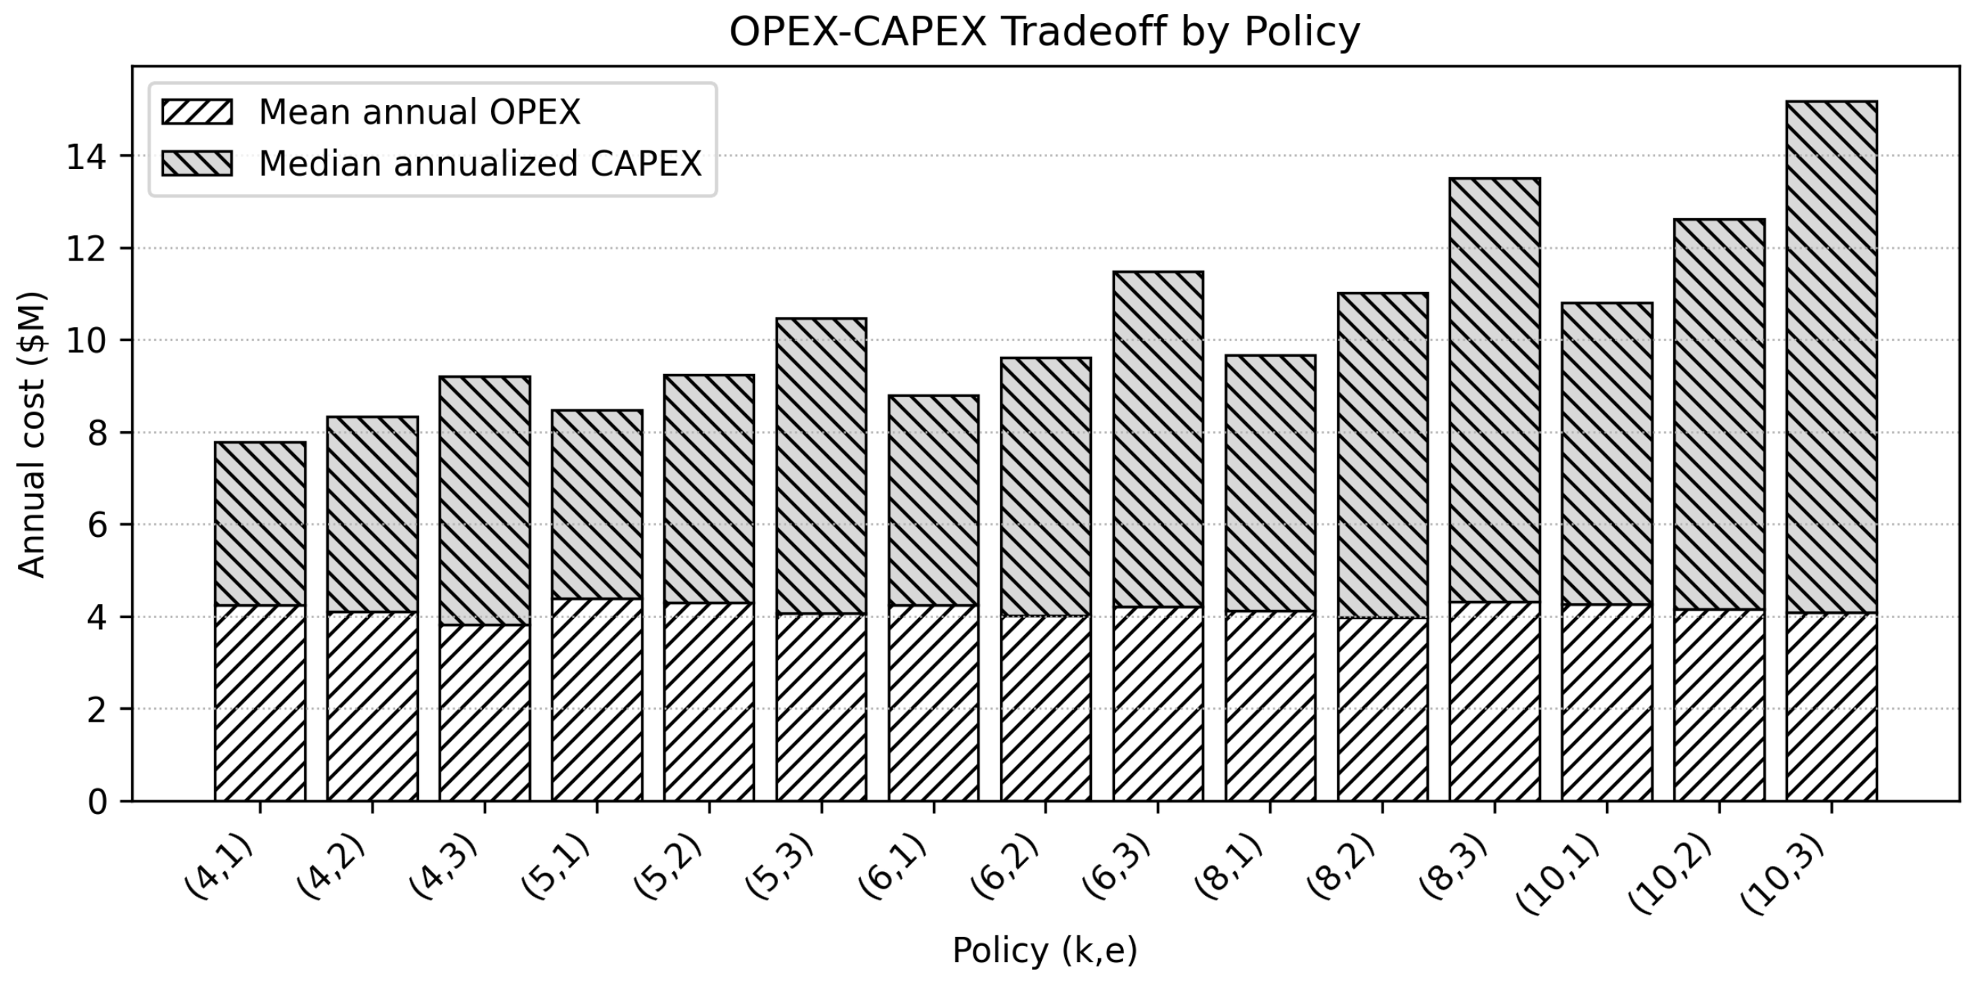
Figure 8: OPEX/CAPEX Tradeoff by Policy
The key result is that the operating optimum and the investment optimum are not necessarily the same. In the tested scenarios, the lowest operating-cost policies tend to involve stronger service configurations, while the lowest combined-cost policies tend to remain closer to the low-$k$, low-$e$ region. This is not because better service fails operationally; rather, its operating benefit is not always large enough to offset the annualized capital burden.
Figure 9 shows the same result as a policy surface. The combined annual cost rises most clearly when both $k$ and$e$ are increased. This reinforces the economic interpretation: de-icing capacity planning is not simply a throughput-maximization problem. It is a capital allocation problem in which additional robustness must be justified against its fixed-cost burden.
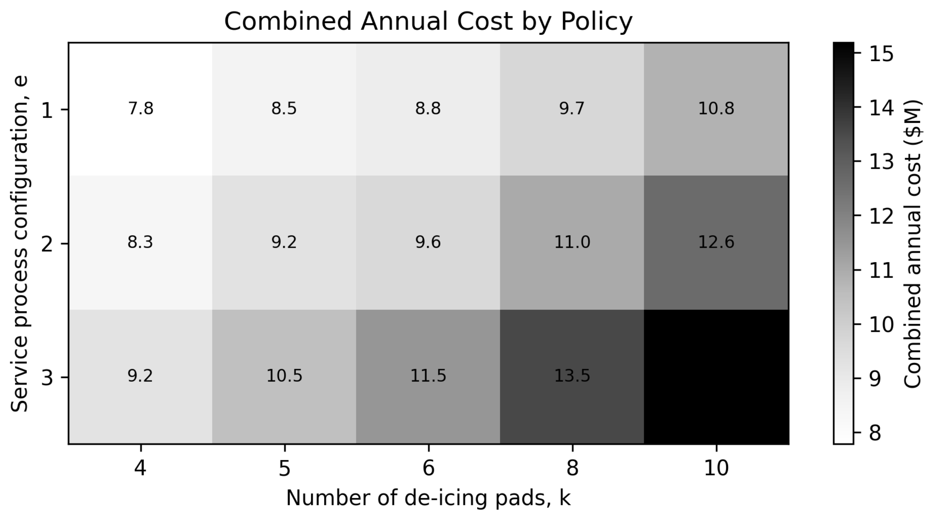
Figure 9: Combined Annualized Cost by Policy ($k, e$)
This result is particularly important because cancellation risk remains significant under many policies. If an airport or airline system places very high value on avoiding cancellation-prone regimes, then higher-capacity or higher-service policies may be justified despite their capital cost. However, under the tested cost assumptions, the CAPEX burden prevents the analysis from recommending maximum capacity as the default choice.
Operationally, the implication is that airports should treat k and e differently. Increasing k requires relatively inflexible physical investment, while improving e may correspond to equipment, staffing, or process improvements that could be more scalable or reversible. The model does not fully capture this real-world flexibility difference, but the CAPEX/OPEX split shows why such considerations matter: operating efficiency alone is not sufficient to determine the preferred capacity policy. This is especially true under misaligned incentives: airlines, which bear cancellation and delay costs, would prefer more aggressive policies, while airports, which primarily bear the CAPEX burden, would not be so inclined.

The storm-frequency experiments also provide a practical interpretation of the CAPEX/OPEX tradeoff. Airports in locales with infrequent winter storms meriting de-icing may rationally tolerate higher disruption risk in exchange for lower fixed infrastructure investment, since severe de-icing conditions occur relatively rarely. By contrast, airports with persistent winter exposure face accumulating costs through repeated disruption and therefore have stronger economic justification for more robust de-icing capability. Thus, the preferred policy is not universal but depends on the long-run weather exposure profile of the airport environment. However, within the tested scenarios, this shift appears gradual rather than abrupt, suggesting that weather frequency changes the economic attractiveness of stronger policies more than it fundamentally changes the underlying congestion mechanisms.
Summary of Results + Synthesis
Taken together, the experimental results suggest that airport de-icing operations are governed less by nominal de-icing throughput alone than by the interaction between de-icing capacity and downstream congestion dynamics. The dominant system mechanism observed throughout the study is HOT-driven recirculation: when downstream taxi/takeoff congestion becomes severe, aircraft increasingly violate holdover time constraints, forcing repeated de-icing cycles that amplify congestion throughout the system.
This recirculation mechanism fundamentally changes the nature of the capacity planning problem. Under low-congestion conditions, de-icing operations behave approximately as an ordinary queueing system in which moderate increases in service quality or server count produce predictable reductions in delay. Under stressed conditions, however, the effective workload becomes partially endogenous. Congestion itself generates additional demand through repeated service cycles, producing nonlinear amplification effects that are not well captured by ordinary first-moment queueing intuition.
The results consistently identify downstream taxi/takeoff conditions as the dominant driver of overall system performance. Variation in downstream congestion and variability produced substantially larger effects than moderate changes in de-icing pad count, service quality, or arrival concentration. This finding has an important operational implication: increasing de-icing throughput alone may fail to improve system-wide performance if downstream operations remain congested. In practical terms, de-icing capacity planning cannot be treated independently from broader airport surface operations.
The comparison between the policy levers $k$and $e$further reinforces this interpretation. Improvements in service process quality generally produced clearer reductions in non-cancellation operating burden than increases in de-icing pad count. However, neither lever alone reliably suppressed cancellations under adverse downstream conditions. This suggests that the dominant operational challenge is not merely insufficient de-icing throughput, but rather the interaction between de-icing operations and downstream congestion feedback.
The cost decomposition results provide a second important interpretation. Under the tested assumptions, cancellation costs dominate total operating expenditure across much of the experimental space. This implies that the system operates in a regime where small changes in cancellation behavior overwhelm comparatively large changes in ordinary operating efficiency metrics such as delay or fluid usage. As a result, total cost becomes partially a proxy for operational feasibility and disruption risk rather than simply a measure of average efficiency.
The CAPEX analysis substantially changes the interpretation of the operating-cost results. Policies that appear operationally attractive when considering OPEX alone may become economically unattractive once annualized infrastructure cost is included. In particular, higher-capacity policies require sufficiently large operating improvements to justify their fixed investment burden. This creates a meaningful tradeoff between robustness and infrastructure expenditure, with preferred policy depending strongly on long-run weather exposure and operational priorities.
The study also highlights important limitations of simplified analytical approximations in congestion-sensitive stochastic systems. The analytical model developed here captures several first-order directional effects under moderate operating conditions, including sensitivity to service quality and arrival concentration. However, it materially understates delay and operating burden in stressed regimes. The primary sources of discrepancy appear to be the model’s first-moment structure, simplified congestion approximation, independence assumptions within the HOT loop, and inability to represent aircraft-level recirculation and cancellations explicitly.
More broadly, the results suggest that nonlinear recirculation dynamics can qualitatively alter the behavior of airport surface operations. Once congestion begins generating additional effective workload through repeated service cycles, system behavior becomes highly sensitive to downstream conditions and difficult to approximate using aggregate flow-based models alone. In this sense, the de-icing system behaves less like an isolated service queue and more like a coupled stochastic network with feedback-driven congestion amplification.
Finally, the results should be interpreted within the scope of the present experimental design. Storm frequency was varied explicitly, but storm severity distributions were not independently perturbed. Similarly, the taxi/takeoff subsystem was modeled as a simplified stochastic service process rather than a full airport surface movement model. The study therefore does not claim to provide a production-grade airport operations model. Rather, its contribution is to demonstrate how stochastic recirculation effects, downstream congestion, and infrastructure tradeoffs interact within a tractable but operationally interpretable modeling framework.
Comparison of Analytic Model and Simulation Results
The analytic approximation is evaluated alongside the DES across all experimental scenarios to assess its ability to capture the dominant system dynamics. The comparison reveals a clear pattern: the analytic model captures first-order congestion trends under moderate conditions but diverges materially in regimes where recirculation and cancellations become significant.

Aggregate Cost Comparison
A direct comparison of total operating cost between the two models is not meaningful in its raw form. The analytic model does not explicitly model cancellations, whereas the DES includes a cancellation mechanism triggered by repeated HOT violations. As shown in the cost decomposition, cancellation costs account for approximately 85–95% of total operating cost across most scenarios. This creates an immediate structural mismatch: the analytic model systematically understates total cost in high-congestion regimes.
Empirically, this manifests as analytic cost approximations being orders of magnitude lower than DES costs in stressed scenarios and in the analytic model exhibiting weak congestion sensitivity vis-à-vis the DES.
This discrepancy is expected rather than pathological. The analytic model treats the system as a steady-state flow with probabilistic thinning, while the DES captures discrete aircraft-level trajectories, including absorbing failure states (i.e., cancellations).

Comparison via Non-Cancellation Operating Cost
To adjust for cancellation dominance and isolate the underlying operational dynamics, the comparison is repeated using a non-cancellation operating cost (delay, fluid, and activation components only).
Under this metric, the analytic model and DES are still strongly disparate (DES cost $≈$ 10x analytic model cost on average across trials), but they are aligned in some meaningful ways. Both predict that increasing service quality via $e$reduces delay cost. Both capture the directionality of arrival-density effects (i.e., reduced congestion via greater temporal dispersion in the arrival process for constant demand). Finally, both show weak sensitivity to server count $k$ in moderate utilization regimes.

Structural Sources of Discrepancy
The persistence of large disparities between the DES and the analytic model in the non-cancellation OPEX suggests that the analytic model is not merely missing the cancellation state – it also understates delay and congestion accumulation before cancellation occurs.
A plausible source of this understatement is the reduced-form taxi/takeoff congestion function used in the analytic model. The analytic model represents downstream congestion through a smooth congestion pressure proxy and assumes that expected taxi/takeoff time follows a functional form of the type $T_{0}+βχ^{p}$. This function is intentionally a heuristic approximation designed to tractably encode congestion-dependence in taxi/takeoff times. However, it is a “queue-like approximation” rather than a true downstream queue. It does not track aircraft-level waiting, queue spillback, burst-induced synchronization, or the realized temporal ordering of aircraft after de-icing. As a result, the analytic model can capture the direction of congestion effects but may substantially understate their magnitude vis-à-vis the rapid, nonlinear explosion of queueing delay that can occur under high utilization in the DES. It must be noted, however, that the relative contribution of this effect versus first-moment approximation error cannot be isolated in the present experiments.
This first-moment structure is another plausible explanation for the analytic model’s shortcomings. The analytic approximation computes expected queueing and sojourn times using pointwise stationary approximations and aggregate flow relationships. As noted in Appendix I, these aggregated PSA estimates are first-order approximations that are vulnerable to breakdown in high-utilization regimes. By contrast, the DES accumulates realized queueing delays at the aircraft level. Since delay costs are convex/piecewise-linear in realized delay, tail events and synchronization effects (i.e., higher-moment structures the analytic model cannot capture) can produce costs that are much larger than those implied by an average-delay approximation.
The HOT loop introduces a second structural mismatch. The analytic model represents HOT recirculation through a congestion-dependent HOT probability and a geometric approximation to the expected number of de-icing cycles. This structure assumes independence between successive HOT violation events, an assumption the appendix explicitly identifies as chosen for tractability rather than realism. The DES, by contrast, tracks individual aircraft histories, so aircraft that violate HOT once may remain exposed to the same congested operating environment on subsequent attempts. This makes repeated violations path-dependent rather than independent.
Third, the analytic model structurally underestimates taxi times relative to the DES. The DES samples a second taxi time (see Appendix II) when sending a HOT violator back to de-icing. This is more reflective of system physicality (aircraft must taxi back to de-icing from the runway and do not appear there instantaneously following a HOT violation). The analytic model does not have a provision for this and thus systematically underestimates ground sojourn times incurred by HOT violators. This is likely a nontrivial contributor to its underestimation of true OPEX.
Finally, the analytic model has no provision for cancellation. This matters most for total cost, since the DES assigns large, explicit cancellation penalties while the analytic model does not. It also changes the physical behavior of the simulated system: in the DES, cancellation is an absorbing state that truncates recirculation after repeated HOT violations. In the analytic model, recirculation is represented only through expected effective workload. Thus, cancellation absence should not be interpreted as implying that the analytic model must always produce larger non-cancellation costs. In the observed results, the larger effect is that the analytic congestion approximation substantially understates the delay and queueing burden that appears in the aircraft-level DES.

Regime-Dependent Validity
Taken together, the results suggest a regime-dependent interpretation. In moderate congestion regimes, the analytic model provides a reasonable approximation of average system behavior and captures directional sensitivities to key parameters. In high-congestion regimes, particularly those characterized by strong recirculation and downstream bottlenecks, the analytic model breaks down, systematically underestimating both delay and total cost. This breakdown is not a failure of implementation, but a consequence of the analytic model’s structural simplifications and inability (by construction) to capture higher-moment-driven behavior.

Implications for Use
The comparison suggests a complementary role for the two models. The analytic model, while imperfect in important ways, is useful for rapid, first-order sensitivity analysis and intuition building. The DES is more comprehensive and reliable and is thus required for accurate evaluation of operational risk, particularly cancellation behavior and congestion amplification. In particular, any decision context in which cancellations are operationally critical cannot rely on the analytic model alone.
Limitations and Future Work
Several limitations of the present study should be acknowledged. Although the modeling framework captures a range of stochastic congestion effects and operational tradeoffs, it remains a simplified representation of a highly complex airport operating environment. The study is therefore best interpreted as a tractable stochastic capacity-planning model rather than a production-grade airport operations simulator.
A central limitation is the treatment of airport ground operations. Real airport surface movement dynamics involve gate assignment, pushback coordination, runway sequencing, taxiway conflicts, routing decisions, terminal interactions, and air traffic control procedures, many of which evolve continuously and interact across multiple spatial and temporal scales. The present study deliberately abstracts away most of this complexity. The de-icing subsystem is modeled explicitly, while the downstream taxi/takeoff subsystem is represented as a reduced-form stochastic delay process with congestion-sensitive service times. This abstraction allows the study to focus on recirculation and capacity-planning effects without constructing a full airport surface movement simulator. However, it also limits the physical fidelity of the downstream congestion dynamics.
Relatedly, the taxi/takeoff subsystem operates under several simplifying assumptions. Taxi/takeoff delay is determined using the instantaneous congestion state observed when an aircraft enters the subsystem, after which the realized service time is sampled and fixed. Subsequent arrivals do not alter the service time already assigned to aircraft in the subsystem. The model also assumes a simplified FIFO-style service discipline and does not represent runway prioritization, sequencing logic, or route-level taxiway interactions. These assumptions are operationally convenient but differ materially from real airport surface operations.
The model also assumes effectively instantaneous transit between several system stages. In particular, aircraft transition immediately between queueing stages once service is completed. Real airports exhibit non-negligible movement and coordination delays between operational subsystems, and these transition dynamics may themselves become congestion-sensitive under stressed operating conditions. The omission of explicit cross-stage transit dynamics is consistent with many reduced-form queueing models, but it remains a limitation of the present framework.
The arrival process constitutes another important simplification. Aircraft arrivals are modeled using a nonhomogeneous Poisson process (NHPP) with Gaussian-pulse structure in order to capture temporally concentrated departure banks in a tractable manner. While this captures an important qualitative feature of real airport operations, it does not constitute a comprehensive representation of airport demand dynamics. Real airport arrival processes may exhibit state dependence, schedule coordination effects, airline-level coupling, and burst structures that are not well represented by the present formulation. In particular, future work could explore Markov-modulated Poisson processes (MMPP) or empirically fitted arrival processes calibrated from real airport data.
The weather process is also treated exogenously. Storm occurrence and storm severity are sampled independently of airport operational state, and the experiments explicitly vary storm frequency but not the underlying storm severity distribution. In practice, severe weather events may alter operational behavior in ways not captured here, including changes in departure scheduling, runway utilization, operational policy, and staffing behavior. Weather events may also persist over multiple days, giving rise to additional operational consequences not explored in this study (which focused only on single-day events). Future work may benefit from incorporating richer weather-process coupling and controlled storm-severity sensitivity analysis.
A broader limitation of the study is the extensive reliance on heuristic approximations and assumed parameter values. The present work was developed primarily as a stochastic modeling and simulation study rather than a calibrated operational forecasting system. Consequently, many distributions, cost coefficients, and behavioral assumptions were chosen heuristically rather than estimated from empirical airport data. This limitation is particularly important for the cost model. The experiments indicate strong cancellation dominance under the tested assumptions, but real airport economics may place different relative weight on delay, fluid consumption, operational disruption, and cancellation outcomes. It is therefore entirely possible that the present model underprices fluid-related operating burden, overprices cancellations, or both. Empirical calibration against real airport operating data would substantially strengthen the operational credibility of the framework.
Several additional modeling assumptions may also materially influence results. The allowable ground-sojourn-time approximation, HOT-limit assumptions, aircraft-type service multipliers, and congestion-sensitivity structure were all modeled using simplified parameterizations. While these assumptions enabled tractable experimentation and sensitivity analysis, the resulting optimal policies may be sensitive to the chosen parameter values and functional forms.
The analytic approximation introduces further limitations beyond those present in the DES. The analytical model relies heavily on first-moment approximations, pointwise stationary assumptions, and simplified congestion relationships. It does not explicitly track aircraft-level trajectories, cancellations, or detailed recirculation history. As demonstrated in the experimental results, these simplifications become increasingly problematic under high-congestion operating regimes, where nonlinear feedback effects and repeated HOT violations materially alter system behavior. The analytical model should therefore be interpreted primarily as a first-order sensitivity-analysis tool rather than a high-fidelity operational predictor.
Finally, the study intentionally focuses on capacity-planning behavior rather than day-level operational optimization. Scheduling policies, dispatch rules, gate coordination strategies, and adaptive operational control were intentionally abstracted away in order to isolate the structural interaction between de-icing capacity, downstream congestion, and stochastic recirculation. Future work may benefit from integrating richer operational decision-making policies into the simulation framework, particularly in conjunction with empirical data and higher-fidelity airport surface movement models.
Project Code
All project code was implemented in MATLAB. The core project code is available at https://github.com/coleshaigec/De-Icing-Project.
Visualization and data analysis was performed on an ad hoc basis using Excel and Python.
All experimental configurations, including exact parameter values for arrival processes, service distributions, taxi/takeoff models, and cost parameters, are documented in the project codebase. The simulation pipeline is fully parameterized, and all results reported in this study can be reproduced directly from the provided configuration files.

Selected References
Lewis, P. A. W., & Shedler, G. S. (1978). Simulation of Nonhomogeneous Poisson Processes by Thinning (Technical Report No. NPS-55-78-014). Monterey, CA: Naval Postgraduate School. [Available at: https://hdl.handle.net/10945/63247]
Sakasegawa, H. (1977). An approximation formula $L_q \approx \alpha \cdot \rho^\beta / (1 - \rho)$. Annals of the Institute of Statistical Mathematics, 29(1), 67–75. [https://doi.org/10.1007/BF02480270]
Shaigec, C. H. (2026). ENG ME 714: Advanced Stochastic Processes [Lecture notes]. Department of Mechanical Engineering, Boston University. Taught by James R. Perkins, Spring 2026.
Whitt, W. (1991). The Pointwise Stationary Approximation for $M_t/M_t/s$ Queues is Asymptotically Correct as the Rates Increase. Management Science, 37(3), 307–314. [https://doi.org/10.1287/mnsc.37.3.307]
Appendix I: Full Analytic Approximation
The model presented in this section of the report is a simplified facsimile of the underlying system dynamics. It is intentionally designed as a tractable, approximate analytical scaffold for exploration of system properties and sensitivities. It is not constructed by fitting functions on empirical data or deriving formulae from first principles, and it is not taken as a uniquely correct representation of system dynamics. Instead, the model is constructed as a series of heuristic approximations based on known patterns in airport operations and simplifying assumptions.
Construction of the analytic model begins with the establishment of an external arrival process to the de-icing server. As outlined in System Model, the below Gaussian pulse-modulated non-homogeneous Poisson arrival process is used:
$$λ\left(t\right)≔ λ_{base}+λ_{peak}\exp\left\{\frac{-{\left(t-t_{0}\right)}^{2}}{2σ_{λ}^{2}}\right\}$$
Since the de-icing service system is modeled with a G/G/k structure, Burke’s Theorem cannot be invoked to justify a Poisson structure for the de-icing departure process. For the sake of tractability, this simplified analysis does not aim to specify a full distribution for the de-icing departure process $λ_{DI}^{(out)}$. Instead, a first-order flow-balance relation is used to capture the first moment of this process. Under the assumption of local stability of the de-icing server (i.e., $∀t, ρ_{DI}≔\frac{λ\left(t\right)}{{kμ}_{DI}}<1$), the long-run departure rate from the de-icing server is treated as approximately equaling the long-run arrival rate to that server. In other words, the system’s long-run behavior induces:
$$λ_{DI}^{\left(out\right)}\left(t\right)≈λ_{eff}\left(t\right)$$
This first moment is useful but not sufficient to adequately specify the departure process from the de-icing subsystem. Variance in de-icing interdeparture times may create congestion that impacts $λ_{eff}$ by shaping the stochastic structure of HOT violations downstream. To capture this effect, the lumped-parameter taxi/takeoff model $T_{departure}$ is coupled to the de-icing departure process using a congestion pressure proxy.
For this purpose, the de-icing server utilization is defined as
$$ρ_{DI}≔\frac{λ_{eff}E\left[T_{DI}\right]}{k}<1$$
using the scenario-specific mean de-icing service time $E\left[T_{DI}\right]$. It is restricted to be less than one by the assumption of local stability. Then, a proxy for the taxi/takeoff congestion-inducing properties of de-icing process variance is constructed as
$$α_{DI}≔1+ηρ_{DI}$$
where $η$ is a congestion propagation sensitivity parameter. This enables construction of the taxi/takeoff congestion pressure proxy
$$χ_{Departure}≔ρ_{Departure}α_{DI}$$
where
$$ρ_{Departure}≔\frac{λ_{DI}^{\left(out\right)}}{μ_{Departure}}$$
for effective taxi/takeoff service rate $μ_{Departure}$.
To couple the taxi/takeoff sojourn time $T_{Departure}$ to the second-order structure of the de-icing service process, a family of congestion functions $ϕ_{Departure}(χ_{Departure})$ is explored. In the absence of suitable empirical data from which a functional form for $ϕ_{Departure}$ can be estimated, the following structure is conjectured based on qualitative system properties and subjected to a sensitivity sweep in the parameters $β$ and $p$:
$$\begin{aligned}ϕ_{Departure}\left(χ_{Departure}\right)≔β{\left(χ_{Departure}\right)}^{p} \end{aligned}$$
This power law functional form is conjectured as an approximation to queue-like behavior for the lumped-parameter taxi/takeoff service model, aimed to reproduce the convex delay growth observed in queues. $ϕ_{Departure}$ monotonically increases in $χ_{Departure}$, concordant with the effects of congestion on sojourn time. The congestion sensitivity parameter $β$ modulates this effect, while the parameter $p$ introduces nonlinearity resembling the explosive sojourn time increases in queueing systems as utilization grows large.
Using the congestion function $ϕ_{Departure}$, the conditional distribution of $T_{departure}$ given $χ_{Departure}$ is defined such that
$$\begin{aligned}E\left[T_{Departure}\right| χ_{Departure}] :=T_{0}+ϕ_{Departure}\left(χ_{Departure}\right) \end{aligned}$$
or, equivalently,
$$E\left[T_{Departure}\right| χ_{Departure}] :=T_{0}+β({χ_{Departure})}^{p}$$
where $T_{0}$ is the baseline, zero-congestion taxi/takeoff time. This structure explicitly accounts for taxi/takeoff congestion effects induced by de-icing process variance. Taxi/takeoff is inherently a multi-stage process, with service times having positive support and a degree of right-skewness due to bursts of arriving aircraft, weather, and/or congestion. While many distributions (e.g., lognormal) reliably capture this effect, a Gamma distribution is chosen as a first approximation for this conditional structure of $T_{Departure}|χ_{Departure}$ for the sake of tractability:
$$\begin{aligned}T_{Departure}|χ_{Departure} \sim Γ(α_{T}, θ_{T}) \end{aligned}$$
where:
$$\begin{aligned}α_{T} :=\frac{1}{C_{T}^{2}}\end{aligned}$$

$$\begin{aligned}θ_{T}(χ_{Departure}) :=C_{T}^{2}E\left[T_{Departure}\right|χ_{Departure}]\end{aligned}$$
where $C_{T}$ is the coefficient of variation for $T_{Departure}$:
$$\begin{aligned}C_{T}(χ_{Departure})≔\frac{\sqrt{Var\left[T_{Departure}|χ_{Departure}\right]}}{E\left[T_{Departure}|χ_{Departure}\right]}\end{aligned}$$
It then follows from the above that:
$$q\left(χ_{Departure}\right)≔ P\left[T_{Departure}>T_{HOT}|χ_{Departure}\right]=1-F_{Γ}\left[T_{HOT};α_{T}\left(χ_{Departure}\right), θ_{T}(χ_{Departure})\right]$$
where $F_{Γ}\left(•\right)$ is the Gamma distribution CDF.
With the instantaneous congestion-conditional HOT violation probability $q\left(χ_{Departure}\right)$ in hand, it is possible to concretize the effective de-icing arrival rate according to the following stochastic fixed-point problem:
$$\begin{aligned}λ_{eff}(t)= \frac{λ(t)}{1-q(λ_{eff}, k,e)}\end{aligned}$$
where:
- $λ_{eff}(t)$ is the effective arrival rate to the de-icing server at time $t$
- $λ(t)$ is the external arrival rate to the de-icing server at time $t$
- $q(λ_{eff}(t), k,e)$ is the probability of a HOT violation at time $t$given the capacity decision (k, e)
Given the necessary scenario-specific constants and parameters, this fixed-point relation is solved iteratively in code to specify the dynamics of the system.
A set of derived performance metrics is now constructed using the formulae above. These metrics, when combined with other problem parameters and passed through the economic model defined later, are sufficient to elucidate de-icing capacity planning tradeoffs of operational interest. Since many problem parameters are time-varying and/or conditional on the instantaneous congestion proxy $χ_{Departure}(t)$, closed-form solutions for expectation-based metrics are difficult to obtain.
To overcome this challenge, instantaneous values of these metrics are computed as pointwise stationary approximations (PSA) using local parameter values and aggregated over the analysis horizon as needed. It is again noted that this choice is oriented around tractability over realism. The PSA framework (Whitt, 1991) is used to approximate time-varying performance by evaluating stationary queueing approximations at instantaneous arrival rates. This approach is theoretically justified for exogenous arrival processes under increasing-rate asymptotics. In this work, PSA is extended to a G/G/k setting using Sakasegawa’s approximation and embedded within a feedback system governing effective arrivals. These extensions move beyond the formal guarantees of PSA and should be interpreted as first-order approximations, particularly under high-utilization or strongly path-dependent regimes.
Airline networks are tightly coupled systems with high sensitivity to delay, so many of the metrics in this analysis will focus on the delay structure induced by a given capacity planning decision (k, e) and its economic consequences.
First, the expected total ground sojourn time for an aircraft is analyzed. Even with the ground sojourn process simplified to a two-stage de-icing plus taxi/takeoff system, it is not sufficient to simply sum the expected sojourn times at these stages since the HOT violation feedback loop may cause an aircraft to visit de-icing multiple times. Thus, the expected ground sojourn time $E\left[T_{Ground}\right]$ is obtained by the decomposition:
$$E\left[T_{Ground}\right]=E\left[J_{DI}^{(aircraft)}\right]\left[E\left[W_{q}\right]+E\left[T_{DI}\right]\right]+E[T_{Departure}]$$
where:
- $E\left[J_{DI}^{(aircraft)}\right]$ is the expected number of de-icing jobs required per external aircraft
- $E\left[W_{q}\right]$ is the expected de-icing queueing delay
- $E\left[T_{DI}\right]$ is the expected de-icing service time, taken as a scenario-specific constant
- $E[T_{Departure}]$ is the expected taxi/takeoff sojourn time, as established earlier
The expected number of de-icing jobs required per external aircraft $E\left[J_{DI}^{(aircraft)}\right]$ is computed using a time-aggregated geometric PSA approximation to address temporal variation in the HOT violation probability $q$:
$$E\left[J_{DI}^{\left(aircraft\right)}\right]=\frac{1}{1-\overline{q}}$$
with
$$\overline{q}≔\frac{\int_{0}^{T}{λ_{eff}\left(t\right) dt}}{\int_{0}^{T}{λ(t)}dt}$$
Like many other features of the analytic approximation, this structure is chosen for tractability over realism: it assumes independence between successive HOT violation events, which is not strictly valid due to temporal congestion correlation.
Given the G/G/k structure of the de-icing server, the PSA mean queueing delay $E\left[W_{q}^{(instantaneous)}\right]$ at de-icing may be approximated using the Sakasegawa formula as:
$$E\left[W_{q}^{(instantaneous)}\right]≈\left(\frac{ρ_{DI}^{ \sqrt{2\left(k+1\right)}-1 }}{k\left(1-ρ_{DI}\right)}\right)\left(\frac{C_{a}^{2}+C_{s}^{2}}{2 }\right)\left(E[T_{DI}]\right)$$
where $C_{a}$ and $C_{s}$ are the coefficients of variation for de-icing interarrival times and service times, respectively. This too is a choice aimed at tractability: this formula, obtained from Sakasegawa (1977), is a steady-state approximation for mean waiting time in stable queueing systems with no feedback. Its use in this context as a pointwise stationary approximation for the behavior of a queueing system with nonlinear feedback dynamics is thus a tractable first-order approximation rather than an exact characterization of system characteristics, especially in high-utilization regimes. The PSA approximation further assumes that the system equilibrates rapidly relative to changes in arrival intensity, which may not hold under heavy congestion or strong recirculation.
As an illustrative example of PSA, the Sakasegawa approximation is aggregated over time to obtain a traffic-weighted mean queueing delay as:
$$E\left[W_{q}\right]≈\frac{\int_{0}^{T}{λ_{eff}\left(t\right)E\left[W_{q}^{\left(instantaneous\right)}\right](t)}dt}{\int_{0}^{T}{λ_{eff}\left(t\right)dt}}$$
This is done in code, where it is implemented as a Riemann sum over a uniform time grid under the form
$$E\left[W_{q}\right]≈\frac{\sum_{i}{λ_{eff }(t_{i})E}\left[W_{q}^{\left(instantaneous\right)}\right]\left(t_{i}\right)∆t}{\sum_{i}{λ_{eff }\left(t_{i}\right)∆t}}$$
Other expectation-based metrics (e.g., expected ground sojourn time) are approximated using similar aggregations of PSA estimates. Flow-based metrics (e.g., expected number of HOT violations) are approximated using a different aggregation strategy, illustrated for HOT violations on $[0,T]$:
$$E\left[N_{Violations}\right]≈\int_{0}^{T}{λ_{eff}\left(t\right)}q\left(t\right)dt≈\sum_{i=0}^{T}{λ_{eff}\left(t_{i}\right)q\left(t_{i}\right)∆t}$$
This discretized aggregation directly implements the PSA framework by approximating time integrals of stationary performance measures evaluated at instantaneous arrival rates.
Combining the previous results yields the following closed-form expression for the expected ground sojourn time:
$$E\left[T_{Ground}\right]= \frac{1}{1-\overline{q}}\left[\left(\frac{ρ_{DI}^{ \sqrt{2\left(k+1\right)}-1 }}{k\left(1-ρ_{DI}\right)}\right)\left(\frac{C_{a}^{2}+C_{s}^{2}}{2 }\right)\left(\frac{1}{μ_{DI}}\right)+E\left[S_{E}\right] \right]+T_{0}+βχ_{Departure}^{p}$$
In addition to delay behaviors via the expected ground sojourn time and its components, metrics related to airside workload and congestion are of operational interest.
The total expected number of de-icing jobs in $[0,T]$ is computed as:
$$E\left[J_{DI}^{(airport)}\right]=\int_{0}^{T}{λ_{eff}\left(t\right)dt}$$
Expected traffic volumes at de-icing and taxi/takeoff may be obtained using a pointwise stationary Little’s Law approximation:
$$E\left[N_{DI}\right]=\frac{1}{E\left[T_{DI}\right]}\left(E\left[S_{E}\right]+E\left[W_{q}^{(instantaneous)}\right]\right)=\frac{E\left[W_{q}^{(instantaneous)}\right]}{E\left[T_{DI}\right]}+1$$
$$E\left[N_{Departure}\right]=μ_{Departure}E\left[T_{Departure}\right]$$
Higher-order moment and tail-risk metrics (e.g., variance of delay, probability of extreme delay events) are operationally important but difficult to obtain analytically under the present G/G/k and time-varying structure. These quantities are therefore estimated via Monte Carlo simulation in the full DES model. The analytical model focuses on first-moment approximations and structural sensitivities, while the DES is used to capture tail behavior and transient congestion effects.

Appendix II: DES Methodology
The discrete-event simulation (DES) was developed to address several structural limitations of the analytical approximation. The analytical model relies heavily on pointwise stationary approximations (PSA), Sakasegawa-style queueing approximations, and first-moment congestion relationships applied in a setting with nonlinear feedback, recirculation, and cancellation behavior. While these approximations provide useful first-order intuition, they are not designed to fully capture higher-order queueing effects, aircraft-level recirculation dynamics, or cancellation-driven operating regimes.
In particular, the analytical model relies primarily on first-moment approximations and aggregate flow relationships, cannot capture aircraft-level path dependence, does not represent realized queue buildup or synchronization effects explicitly, and contains no explicit cancellation mechanism.
These limitations are operationally important because the experimental results indicate that tail behavior, recirculation amplification, and cancellations are major drivers of total operating cost. The DES was therefore introduced to explicitly model aircraft-level state evolution and nonlinear congestion feedback.
The DES models airport de-icing operations as an event-driven stochastic system. Aircraft are represented explicitly as entities that evolve through multiple operational stages, including arrival, de-icing queueing, de-icing service, taxi/takeoff processing, HOT violation handling, and departure or cancellation.
The primary aircraft state variables include:
- arrival time
- queue-entry and service-entry timestamps
- de-icing completion time
- taxi/takeoff completion time
- HOT status
- cancellation status
- cumulative system time
The simulation also tracks operational resources explicitly. The de-icing subsystem is represented as a multi-server queue with $k$ parallel de-icing pads. Each server maintains its own busy/idle state and associated aircraft assignment. Queueing is managed explicitly via dedicated FIFO queue structures.
The simulation evolves through an event calendar architecture. Future events are stored chronologically and processed sequentially in increasing time order. Key event types include:
- aircraft arrival
- de-icing service completion
- taxi/takeoff completion
- HOT violation detection
- HOT-driven return-to-de-icing events
A particularly important modeling decision concerns HOT violations and work conservation. Rather than immediately reinserting aircraft into de-icing service upon HOT expiration, the simulation schedules explicit HOT-return events and routes aircraft back through the queueing system. This preserves the work-conserving nature of the de-icing subsystem and prevents aircraft from bypassing queue competition after violating HOT constraints. The resulting recirculation dynamics therefore emerge endogenously through competition for finite service capacity rather than through externally imposed workload adjustments.
This work-conserving treatment is important because the primary phenomenon studied in the project is congestion amplification through repeated service cycles. The simulation was intentionally designed so that repeated de-icing demand consumes real system capacity rather than acting as a purely accounting-level correction.
The downstream taxi/takeoff subsystem is modeled as a reduced-form stochastic service process rather than a full airport surface movement model. Aircraft entering the subsystem receive taxi/takeoff service times drawn from congestion-sensitive Gamma distributions parameterized by the instantaneous system state observed at subsystem entry. The subsystem therefore captures congestion-sensitive departure delay behavior without explicitly resolving taxiway topology, runway sequencing, or route-level aircraft interactions.
The simulation outputs are estimated using Monte Carlo aggregation across multiple stochastic realizations. For each scenario, the DES computes both operational and economic performance metrics. Operational metrics include:
- total departures
- HOT violations
- cancellations
- cancellation rate
- queueing delay
- total system sojourn time
Economic metrics include:
- delay-related operating cost
- fluid cost
- activation cost
- cancellation cost
- total operating cost
Daily simulation statistics are aggregated into annualized estimates across stochastic weather realizations and operational scenarios. These annualized outputs are then used for policy comparison, sensitivity analysis, and comparison against the analytical approximation.
The DES is not intended to serve as a production-grade airport surface movement simulator. Rather, it is designed as a tractable stochastic experimentation framework for studying how recirculation, downstream congestion, and de-icing capacity interact under uncertainty.

